Sponsor and Vendor Invitation

Indiana School Resource Officers Association 9th Annual Conference
Michigan City, Indiana
June 23—25, 2021

ATTENTION ALL SPONSORS
The Indiana School Resource Officers Association invites you to be part of our exciting, growing organization that provides training to school safety professionals and juvenile workers including school based law enforcement, K-12 administrators, superintendents, and more. This year we return to Michigan City, uniquely situated on the Indiana/Michigan border. INSROA is firmly aligned with the Indiana Department of Education and the National Association of School Resource Officers. We have built a strong and dedicated membership base from all over the state of Indiana. Last year’s annual conference had over 200 attendees. We ask you to support an organization that “Sets the standard for school safety in Indiana”.

INSROA Mission Statement:
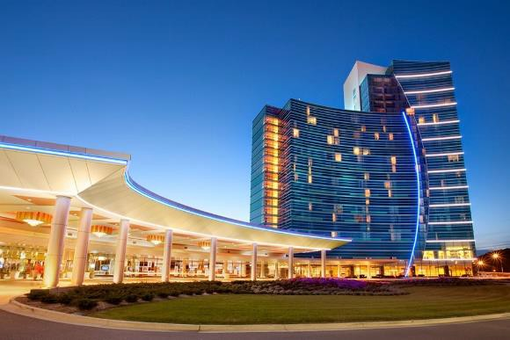
INSROA exists to promote safe learning environments in Indiana schools by providing high quality training, building relationships, and connecting members to resources

THE VENUE:

Blue Chip Hotel 777 Blue Chip Dr
Michigan City, IN 46360

Offering an expanded vendor area filled with natural lighting and located immediately outside of the main conference halls.

THE EVENTS

Tues, June 22nd
Guest Reception and Vendor Fair

Wed, June 23rd
Conference Registration Regular Breaks for Vendor Visits Member Dinner / Sponsor Hour (All sponsors/vendors can address the membership)

Thurs, June 24th
Regular Breaks for Vendor Visits Evening Member Activity (Sponsors/vendors encouraged to attend all member events)

Fri, June 25th
Final 1/2 day of conference

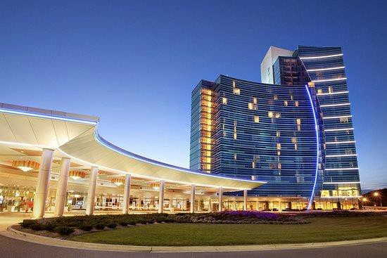
- Logo on conference banner, social media, monthly newsletters, and website
- Complementary vendor table

- All the above PLUS
- Time to speak about your company or product to the members at the member lunch

Silver Sponsor $500
INSROA SPONSOR AND VENDOR INVITATION
JUNE 23-25, 2021
BLUE CHIP CASINO HOTEL AND SPA
- Logo on social media and website
- Vendor Table at Conference

Gold Sponsor $750

Platinum Sponsor $1000

Naming Sponsor $5000 (limited to one company)
- Naming Sponsor will have largest logo on all INSROA banners, website, t-shirts, and quarterly newsletters.
- Complementary vendor table at premier location.
- Complementary table for 8 at the member dinner

PLEASE CIRCLE LEVEL OF SPONSORSHIP

COMPANY NAME:
CONTACT NAME:
ADDRESS:
PHONE:
EMAIL:
INSROA TAX ID# 61-1652239
Please mail this form and check to: INSROA

PO BOX 1323
Bloomington IN 47402

Please email your logo to administrator@insroa.org James Witmer Director of Operations

The INSROA website allows for credit card payment for sponsorship. Please send this completed form to the administrator email along with your logo.

